Nested Virtual Machines

Table of Contents

Overview 2

Definitions 2

Activity 1 – VM Reconfiguration 3

Activity 2 – VM Player Installation 4

Activity 3 – Create Nested VM 5

Nested VM creation and configuration 5

Install Open-VM Tools 7

Shared Folders 7

Nested VM Usage/ Troubleshooting 8

Start-up/Shutdown 8

Full Screen Mode 8

Guest 8

Nested 8

Persistent VMware tools install prompt 9

Table of Figures

Figure 1 Nested VM - Diagram 2

Figure 2 VMware Workstation - Memory adjustment 3

Figure 3 VMware Workstation - Enable Virtualise settings 3

Figure 4 VMware Player Version Select 4

Figure 5 VMware Workstation Linux Download 4

Figure 6 VMware Player - Ubuntu Dash 4

Figure 7 VMware Player Lock to launcher 4

Figure 8 VMware Player Create Nested VM #1 5

Figure 9 VMware Player Create Nested VM #2 - Networking 5

Figure 10 VMware Player Create Nested VM #3 - Select ISO 6

Figure 11 VMware Player Create Nested VM #4 - OS/User Credentials 6

Figure 12 VMware Player - Shared Folders 7

Figure 13 Nested VM Usage - Shutdown procedure 8

Figure 14 Nested VM Usage - Full screen on Guest 8

Figure 15 VMware Tools - Installation Prompt 9

# Overview

In today’s lab we will be upgrading the performance of our current Ubuntu Virtual Machine to allow it to run another Virtual machine inside it.

This is known as **Nested Virtual Machines**. Instead of having two virtual machine running separately from each other they will be running on top of one another.

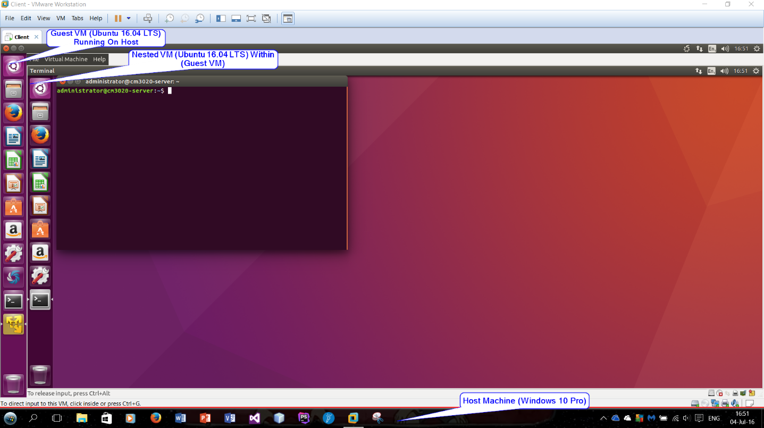

Figure 1 Nested VM - Diagram

# Definitions

|  |  |  |
| --- | --- | --- |
| Term | Definition | Example |
| VM | Virtual Machine: is an emulation of a particular computer system | Client |
| Nested VM | A nested virtual machine is a virtual machine contained within another VM. | Ubuntu 16.04 LTS Running on top of Guest. |
| Host | A host system (host operating system) would the primary & first installed operating system | Windows 10 Professional |
| Guest | A guest system is a virtual machine that is installed under the host operating system (see above). The guests are the VMs that run in your virtualisation platform (see below). | Ubuntu 16.04 LTS |
| Hypervisor | A hypervisor or virtual machine monitor (VMM) is a piece of computer software that creates and runs virtual machines. | VMware workstation/ Virtual box |

# Activity 1 – VM Reconfiguration

Prior to getting the Nested VM working there is some preparation that is required on the Current Virtual Machine.

1. Start-up VMware Workstation but **don’t** start the client Ubuntu VM just yet.
2. On the left hand side click on the ‘Edit virtual machine settings’ option
3. The first device that will require changing is **memory**:
   * The memory is currently set to 1GB (1024MB) we need to set it to 5GB
   * The simplest way to do this is to type 5120 into the textbox

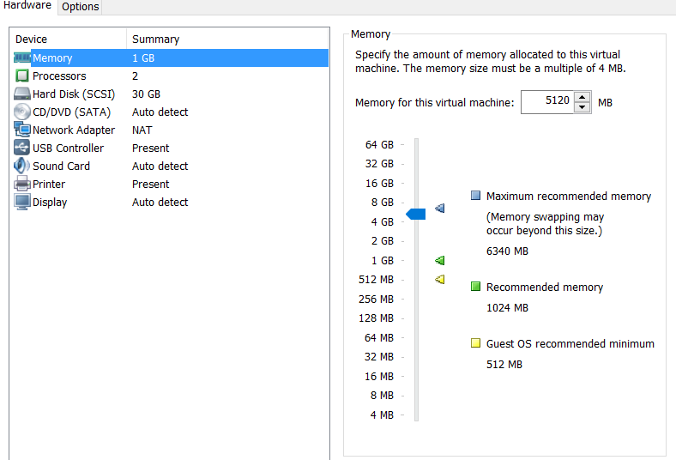

Figure 2 VMware Workstation - Memory adjustment

1. The second device that is will be updated is the **Processors**
   * To enable the Client Ubuntu VM to run 64 bit Nested VMs the ‘virtualize intel vt-x/ept or amd-v/rvi’ option must be ticked.

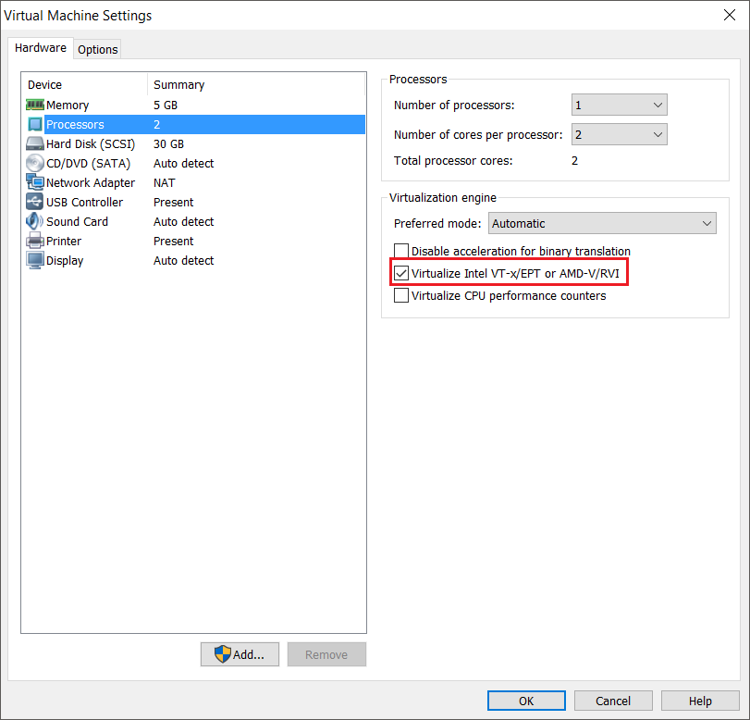

Figure 3 VMware Workstation - Enable Virtualise settings

1. Click OK to save updated setting and start the Client Ubuntu VM.
2. Note: The Virtual Machine has a lot more resources allocated to it now so running additional programs in the background alongside VMWare Workstation will reduce performance for both the host computer and guest VM.

# Activity 2 – VM Player Installation

Now the guest VM has it’s setting configured for Nested VM, VMware player 12 Linux now needs to be installed. At the time of writing the current version of VM Workstation Player is 12.11

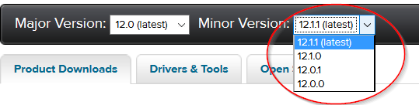

Figure 4 VMware Player Version Select

1. Start up the Ubuntu VM if you haven’t already
2. Start Firefox and navigate to this address: <https://www.vmware.com/go/downloadplayer/>
3. Download the VMware workstation for Linux 64-bit as below:

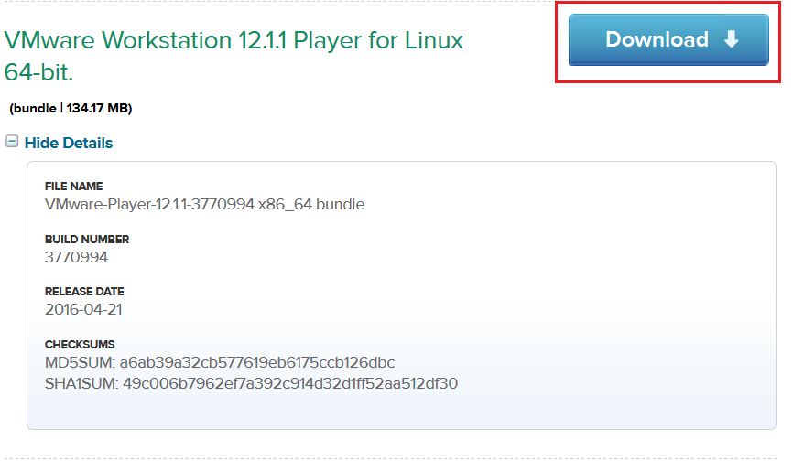

Figure 5 VMware Workstation Linux Download

1. Once the bundle is download, open a terminal window and type in the following commands:
   * cd./Downloads
   * chmod +x VMware-Player-*.bundle
   * sudo ./VMware-Player-*.bundle
2. The installer will now open
   * Accept all the Terms and Conditions
   * Leave the licence field blank
   * Click ‘Install’ to complete installation process.
3. To open the VM Player go the **Ubuntu Dash** and it should be the first application on the list:

|  |  |
| --- | --- |
| Figure 6 VMware Player - Ubuntu Dash | Figure 7 VMware Player Lock to launcher |

* + To save the VM Player to the Launcher Right click on the Icon and click save to launcher.

1. Once the VMware Player opens a licence prompt will appear, select the non-commercial use option and enter your RGU email address: e.g. [matriculationnumber@rgu.ac.uk](mailto:matriculationnumber@rgu.ac.uk)

# Activity 3 – Create Nested VM

## Nested VM creation and configuration

With VMware Player 12 now installed on our Ubuntu Client VM, the Nested VM can now be created. The procedure is almost the same as mentioned in Lab 1 however with a few differences.

1. Open VM Player workstation 12 if not open already
2. Create a New Virtual Machine and select ‘I will the operating system later’:

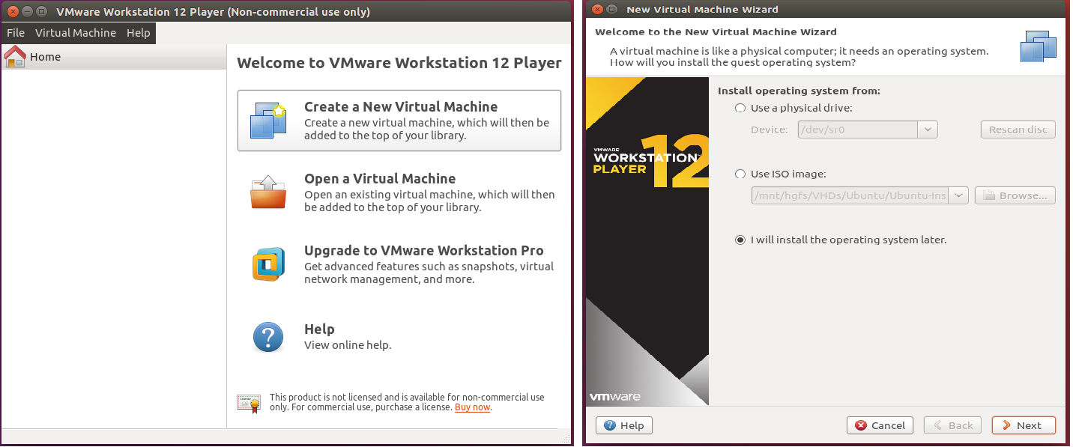

Figure 8 VMware Player Create Nested VM #1

1. For the guest operating system select Linux – Ubuntu 64 bit.
2. Virtual Machine Name: **Server**
3. Virtual Disk Size: 20GB and Store virtual disk as single file.
4. The final review screen should look similar to this:
   * Ensure that the Network Adapter type is NAT (Customize Hardware – Network Adapter – NAT)

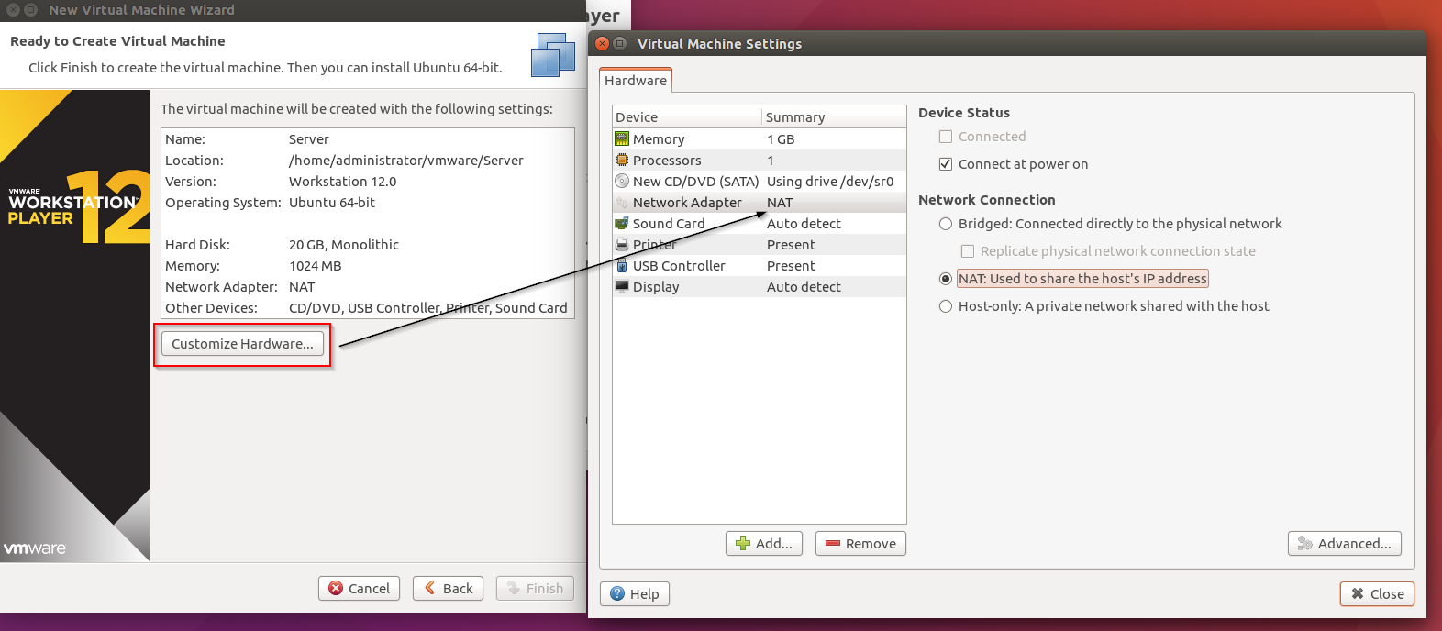

Figure 9 VMware Player Create Nested VM #2 - Networking

1. Click finish then close to complete the creation Process.
2. Click play ‘Virtual Machine’ to start the Nested VM
3. Ignore any warnings of 3D acceleration or VMware tools installation at this stage.
4. Go to Virtual machine settings -> CD/DVD (SATA) – Use ISO Image
   * We’re going to use the same ISO as the Client VM which is stored on the Host File System.

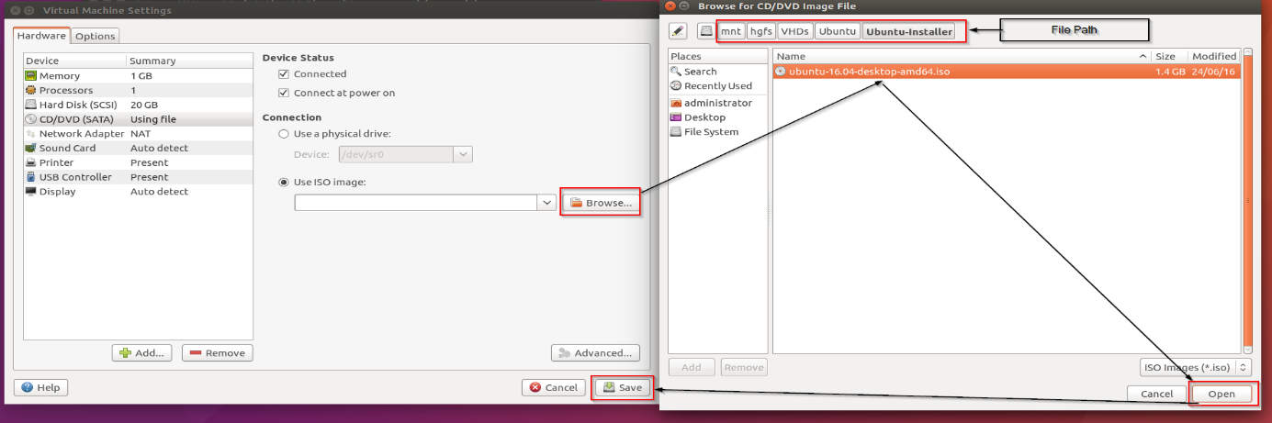

Figure 10 VMware Player Create Nested VM #3 - Select ISO

* + Browse to the following file path:
    - /mnt/hgfs/VHDs/Ubuntu/Ubuntu-Installer/
  + Select the ubuntu-16.04-desktop-amd64.iso – Open then save the settings
  + Reset the VM and follow the instructions for installation as stated in Lab 1 until the user creation stage
    - Note the mouse clicks maybe inconsistent since the VMware Tools aren’t installed yet but be persistent it will work. Alternatively, the keyboard shortcuts will work.
  + At the who are you? Screen – the only difference between the client and server is the host name as below: (cm3020-server)

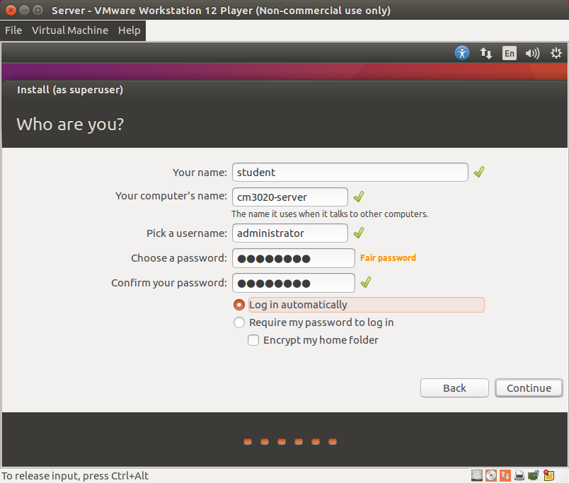

Figure 11 VMware Player Create Nested VM #4 - OS/User Credentials

* + Full name: **student**
  + Username: **administrator**
  + Password: **P@ssw0rd** **Note: The ‘P’ is capitalised and the ‘0’ is a zero.**
  + Select Log in automatically.

## Install Open-VM Tools

Similar in the Client Ubuntu VM – the Open VM tools are also required to be installed on the Server Nested VM.

1. Start the Server Nested VM and open a terminal window
2. Type the following command:

* sudo apt-get install open-vm-tools-desktop

1. In addition to installing open-vm-tools desktop, another vmware toolset is required:
   * Open a terminal window
   * First we need to install git:
     1. sudo apt-get install git
     2. Enter y to continue installation
   * Then we clone the vmware-tools-patches repo from github:
     1. git clone https://github.com/rasa/vmware-tools-patches.git
   * Once the repo is cloned then enter the following commands
     1. cd vmware-tools-patches
     2. sudo ./patched-open-vm-tools.sh
     3. Enter y or yes for any confirmation prompts.
2. Reboot once installation is complete

## Shared Folders

To Access both the Host and Guest File Systems from the Nested VM follow these instructions.

1. Ensure the Nested VM is offline.
   * To access the shared folder settings, go to the Virtual Machine Settings (CRTL+D) then Options
     + Ensure that Always enabled is selected.
     + Click Add button
   * Browse to the //mnt/hgfs/VHDs folder and add Name (VHDs) then OK
   * Save then Restart the Nested VM

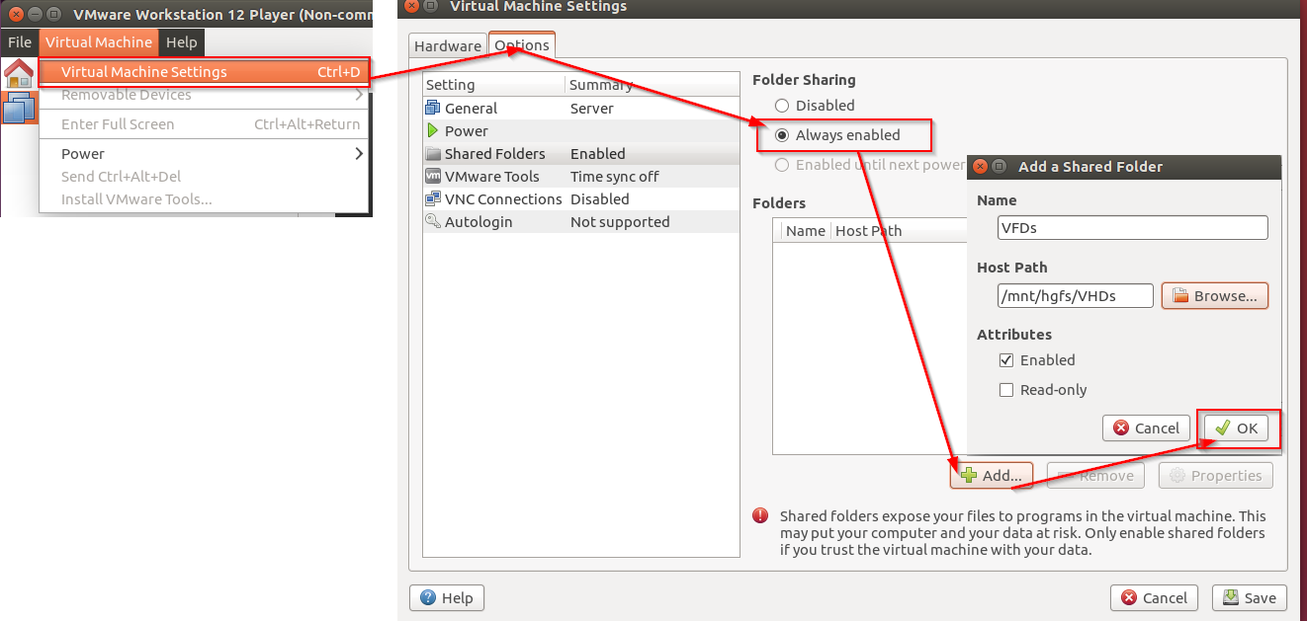

Figure 12 VMware Player - Shared Folders

1. To access these folders in the Nested VM navigate to /mnt/hgfs/VHDs
2. To add additional folders just repeat the process above.

# Nested VM Usage/ Troubleshooting

Congratulations you now have a working Nested VM running on the Guest Ubuntu VM.

As of now there will be 3 operating systems running at one time, so expect the host computer’s performance to degrade as it allocates resources to running both the Guest and Nested VM.

However, here’s a short guide to allow the Nested VM and Guest VM to continue to run smoothly

## Start-up/Shutdown

1. To avoid data corruption, ensure that **both** the nested and Guest VMs are shutdown correctly.
2. The simplest way to do this is to select the settings cog on the top right corner in the nested VM then select shutdown.
3. Repeat this process to shut down the Guest/Client Ubuntu VM.

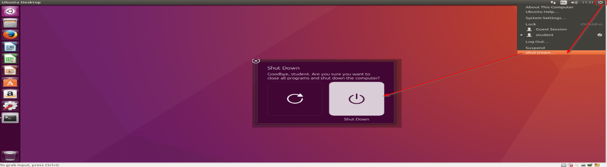

Figure 13 Nested VM Usage - Shutdown procedure

## Full Screen Mode

### Guest

1. To access full screen mode for the Guest VM go to the full screen button

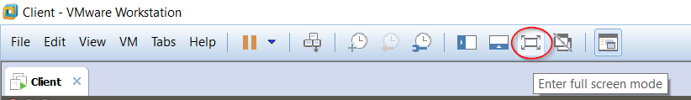

Figure 14 Nested VM Usage - Full screen on Guest

1. Alternatively, full screen can be accessed through the **ctrl+alt+enter** keyboard shortcut.
   * To exit out of full screen mode just reverse the steps above.

### Nested

1. Repeat the steps above then go to Virtual Machine Settings on VMware Player and full screen.
2. To exit out of full screen on nested VM click on the restore down button.

## Persistent VMware tools install prompt

After installing the open-vm-tool and vmware-tool patches you may still get a popup asking to install the vmware-tools when you start up the Nested VM:

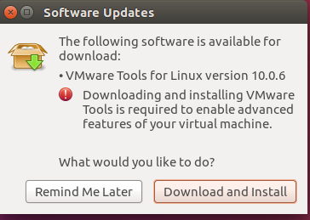

Figure 15 VMware Tools - Installation Prompt

To disable this persistent prompt, the Server.vmx (configuration) file needs to updated.

1. Ensure that VMware Player 12 is closed.
2. Open a terminal window
3. Type in the following commands:
   * cd vmware/Server/
   * gedit Server.vmx
4. Add the following lines at the end of the file:
   * tools.remindInstall = "false"
   * tools.upgrade.policy = "manual"
5. Save and exit
6. Restart Nested VM, the prompt should now be disabled.